Prospective New Member  Forth Group  Chicago, IL | 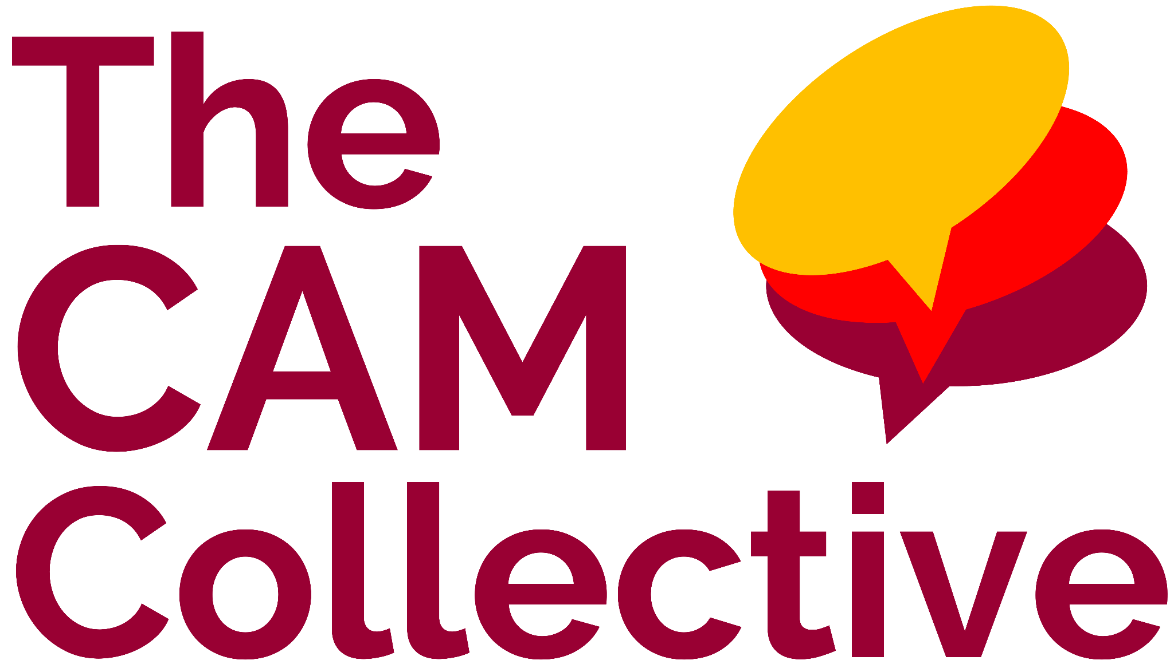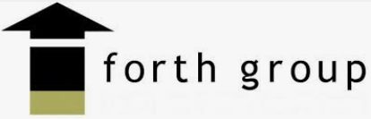
Last Updated: Jun 5, 2025 by Aidan Donaldson

Deal Overview
tl;dr
- Thesis: Acquire a large, growing association management company in our core Chicago market serving small and mid-size condos (similar to W360 customer base)
- Key stats (TTM 3/31/25):
  - $3.8M PF Rev (excludes on-site reimbursable revenue) and $722K of PF Adj. EBITDA (18% margin) before EC opportunity and $909K after EC opportunity (assuming normalized 2.75% fed funds rate + modest transfer fee increase)
    - We had estimated $747K of PF EBITDA in the LOI
  - 172 CAs + 8 rental properties, 7.1K doors
    - 80% condo, 10% townhome, 10% other
    - 50 associations are remote (financial preparation, 4 virtual meetings per year, no inspections or onsite work)
  - 33 FTEs (includes 7 offshore assistants and 6 out of 17 managers who are independent vendors)
  - 6-yr retention: 95% association, 94% door, 79% employee
  - CAM Cut: 51%
  - Revenue Mix: 74% mgmt fees, 5% transfers, 5% earnings credits, 5% maintenance income, 4% other fees, 4% credit card fees, 1% addendum
- Opportunities / Growth:
  - Opportunity to introduce Yellow Jacket maintenance services (new W360 branding) to 170+ associations
  - Very limited addendum billing today; we can slowly introduce addendum fees to increase profitability. Only $0.4/door of addendum billing vs. our other Chicago MCs are near $10/door
  - Current earnings credit agreement with Wintrust only offers 0.50% rates on money market accounts ($17.5M of MM deposits), compared to W360’s current agreement with Wintrust which is FF rate minus 75bps on money market deposits. This is ~$264K of incremental EBITDA assuming a normalized Fed Funds rate of 2.75%.
  - Plug in Forth Group into our HOA sales engine in Chicago to accelerate new client acquisition
- Considerations / Risks:
  - Founder transition from Scott who has run the company for 20 years; it does not seem like there is a clear successor within the company today (PF EBITDA assumes we add back Scott’s pay, increase Scott and Sylwia’s pay $50 each, and hire a controller for $127K)
  - We have converted the 6 independent vendor managers to W-2 employees, which will impact earnings and presents some risk on manager / customer retention (think it is low risk though based on conversations with Seller)
  - The business had increased turnover from 2021 - 2024 (which has since subsided)
- Transition Plan:
  - Roles
    - Scott (CEO / Owner)
      - Handles Forth Group financials, new client development, and his two VPs report to him
    - Sylwia (VP of Ops)
      - Handles all banking relationships
      - All client accounting
      - Oversees customer service team (help desk, front desk)
      - Oversees all of the remote managers
    - Jonathan (VP of Development)
      - Oversees Portfolio Managers (some are employees, some are 1099s)
      - Runs the training, onboarding, and hiring
  - Who is there now that won’t be there post-close?
    - Scott is 64 years old and would like to transition out over the next 2-3 years (may move to Utah with his wife)
- Other relevant info:
  - Forth Group Data Room
  - Forth Group Diligence Workbook
  - Forth Group Info Sheet
  - Forth Group Org Chart
  - Forth Group Diligence Session Notes

Transaction overview
Forth Group, based in Chicago, IL, is an association management company with 33 employees serving 172 CAs + 8 rental properties, and 7.1K units. The communities are almost entirely condo associations with a mix of townhomes, mid-rises, and high-rises. The Company is 90% owned by Scott Seger who founded the Company in 2003. Scott’s VP of Operations and VP of Development each own 5% of the Company. Scott is looking to sell the Company and transition to retirement over the next three years.

Transaction Details
Preliminary Underwriting EBITDA and Valuation (Member Company)
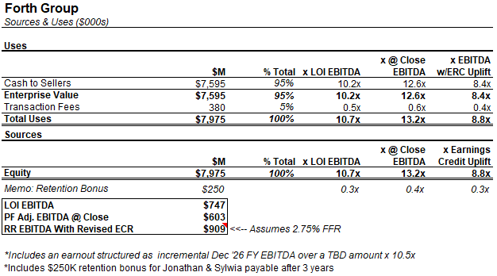

Commentary:

Valuation: In the LOI, we initially valued the Company at 10.2x $747K of estimated EBITDA. QoE EBITDA came in slightly light at $719K (10.6x effective multiple), which further reduces to $603K (12.6x effective multiple) if we burden for the necessary conversion of 1099 managers to W-2 employees.

After reviewing the Forth Group and Westward360 Wintrust earnings credit agreements and speaking with the W360 team, we believe that we can gain an additional $265K+ of earnings credit income immediately after bringing them onto our existing W360 agreement. Additionally, assuming FFR decreases to 2.75%, transfer fees are expected to increase by $43k. The pro forma earnings after converting managers to W-2 employees and transferring the earnings credit agreement brings our effective EBITDA at close to $909K (or 8.4x effective multiple).

PF EBITDA: In addition to our standard management fee and payroll adjustments, we have assumed a controller hire (Scott handles corporate financials + payroll) and a $50K pay increase for both Jonathan and Sylwia, offset by the eventual phase out of Scott’s salary. We have not made an adjustment on rent, as we assume that Scott (who owns the building) will sign a long-term lease with TCC at the same rent rate that the Company is currently paying.

Bonus Compensation: Retention bonuses paid out to Sylwia and Jonathan after 3 years in the amount of $250K. No

Employment Agreement: Scott would sign an agreement through December 2026 at his current salary, and Sylwia/Jonathan will sign employment agreements through December 2028.

QoE LOI Bridge
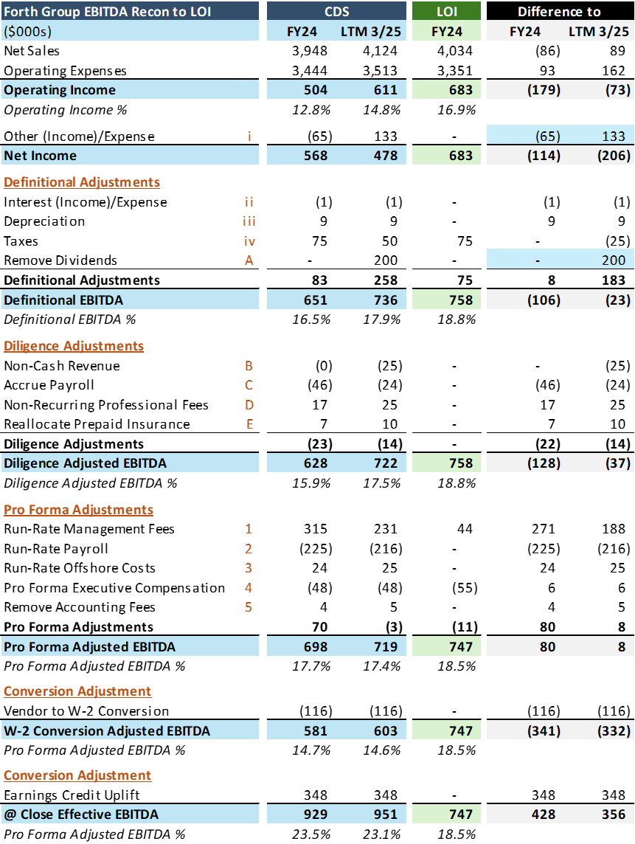

Commentary: QoE earnings came in slightly below our LOI estimated earnings ($719K compared to $747K), however, due to the increased compensation expenses tied to converting six managers to W-2 employees, EBITDA printed 24% lower than our initial underwriting estimates. These managers are currently billed as vendors with their own LLCs as a way to increase their effective earnings through tax deductions. During diligence, we were able to identify a significant earnings credit uplift which results in an effective 27% increase in earnings after switching from the legacy Wintrust agreement over to our Westward360 Wintrust pricing.

Earnings Credit Opportunity
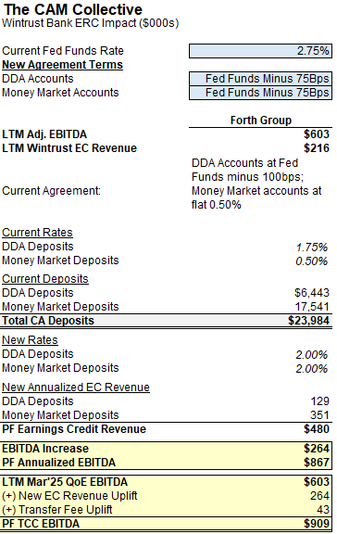
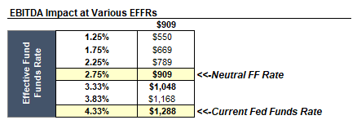
Commentary: Forth currently partners with Wintrust for client banking and receives FF Rate minus 100bps for DDA deposits and a flat 0.50% for MM accounts. W360 also utilizes Wintrust for client banking and receives FF rate minus 75bps for both DDA deposits and MM accounts. We plan to bring Forth Group into the W360 agreement prior to closing.

Potential Employee Classification Issue
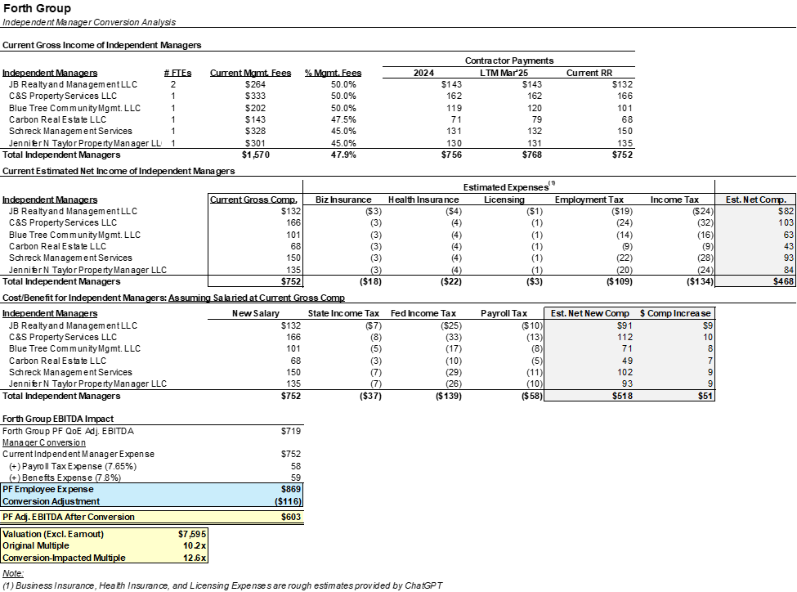

Commentary: Forth Group has 17 managers, 6 of whom operate effectively as contractors with their own individual LLCs. These individuals, who have historically been treated as vendors rather than 1099 contractors, have the same job duties as employee managers, but receive higher compensation (as a percent of management fees) and capture potential tax benefits from being LLCs in exchange for forfeiting benefits and other employment-related protections. Forth has used this model for several years and only does so with managers who willfully elect to be independent.

Labor counsel believes this structure is impermissible, as the independent managers have long-term relationships, work on the Company’s core service offering, and perform the same roles as employees. The associated liabilities include unpaid benefits and PTO (3-year historical statute of limitations) and potential tax penalties for unpaid FICA taxes. Counsel has suggested that we would have to convert these independent managers to W-2 employees. This issue has been preliminarily raised to Scott, but could introduce significant turbulence to the deal in the event that impacted managers elect to step away from the Company. The financial impact of the conversion would be roughly $116K (16% of earnings), which would reduce EBITDA from $719K to $603K and thereby increase our effective multiple from 10.2x to 12.6x. Given the labor model was known at the time of LOI, we do not propose recutting the deal economics; however, we will also not adjust the earnout thresholds for the conversion.

Underwriting Model
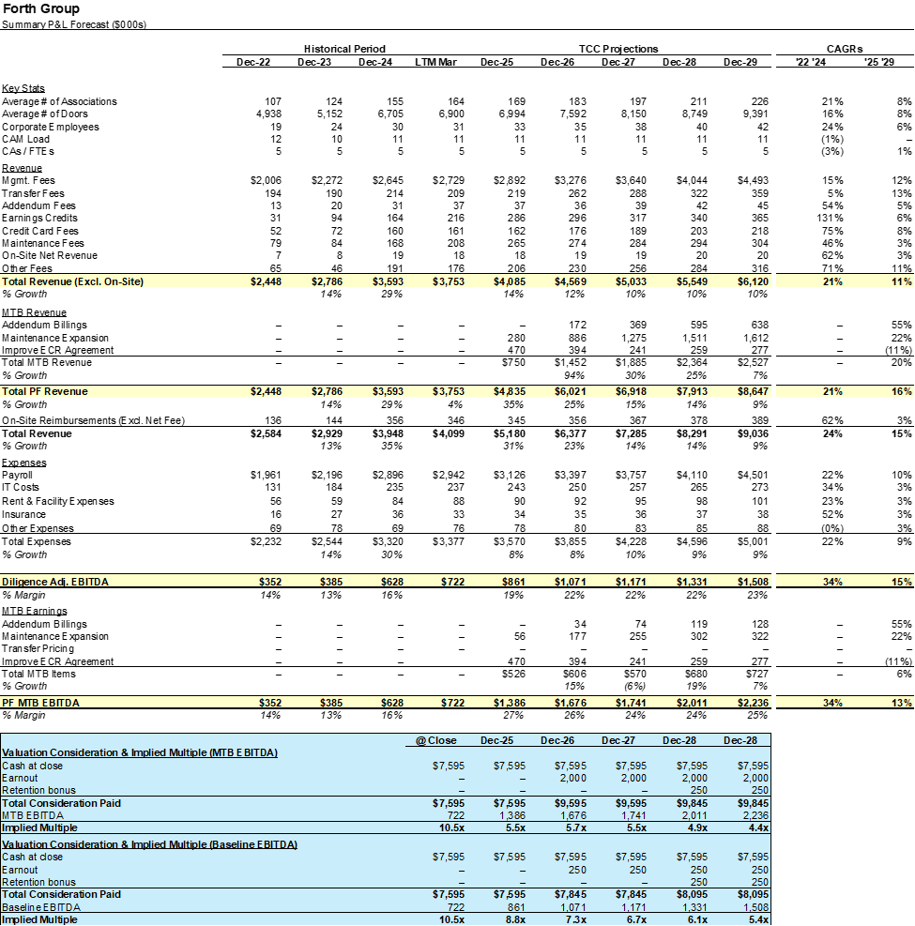

Commentary: Forth Group’s underwriting model assumes baseline customer retention and client wins in-line with the company's historical performance. The difference between our FY ‘25 PF EBITDA of $861K and our QoE PF TTM Mar ‘25 EBITDA of $603K is due to (1) a $95K revenue benefit from increased maintenance income (driven by a large new client win in late ‘24) and bank earnings credits, (2) a $113K reduction in payroll expenses due to the timing of hires, and (3) shifting the executive compensation to 2026 with when Scott would step away from the business ($50K).

Historical P&L Overview
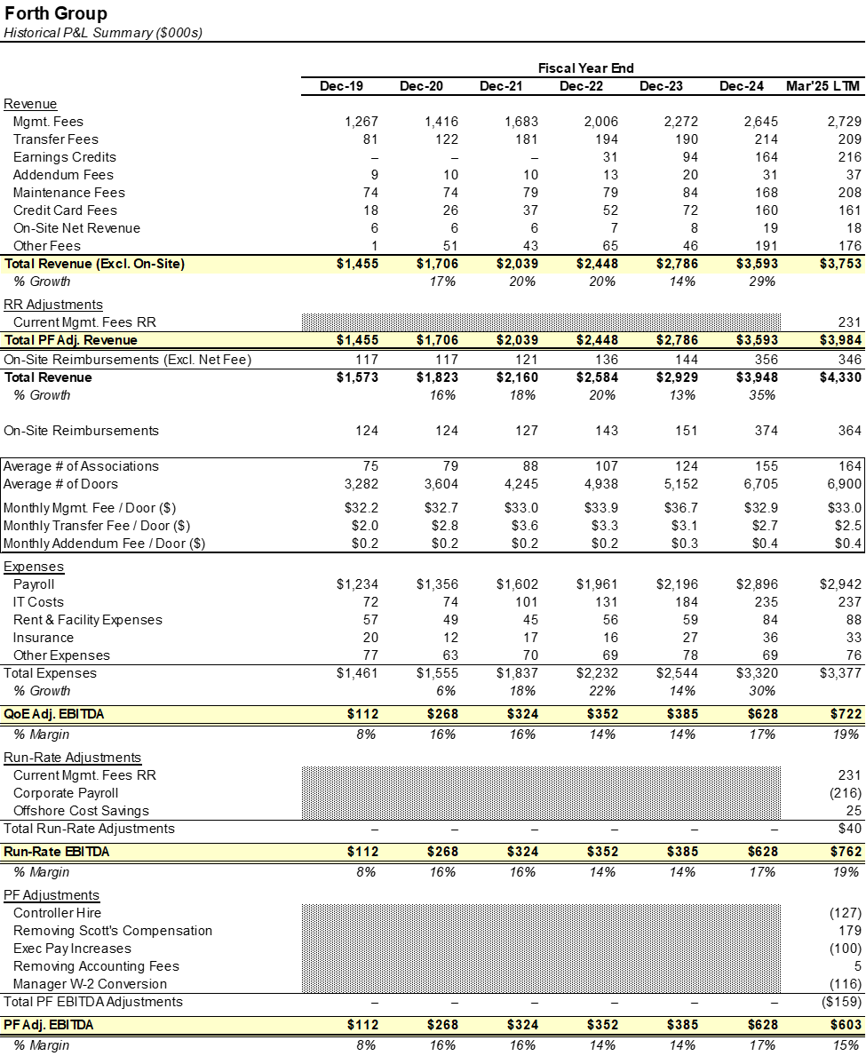

Commentary: Forth has consistently grown topline, driven primarily via management fees on an expanding book of business (see further discussion below on client growth). The company renegotiated its EC agreement in 2024, resulting in an uptick in revenue; there is still room for optimization compared to other agreements. Maintenance growth has largely derived from a small number of accounts who utilize on-site engineers; general maintenance, such as that provided by Yellow Jacket, is largely unpenetrated at this point.

Customer Overview
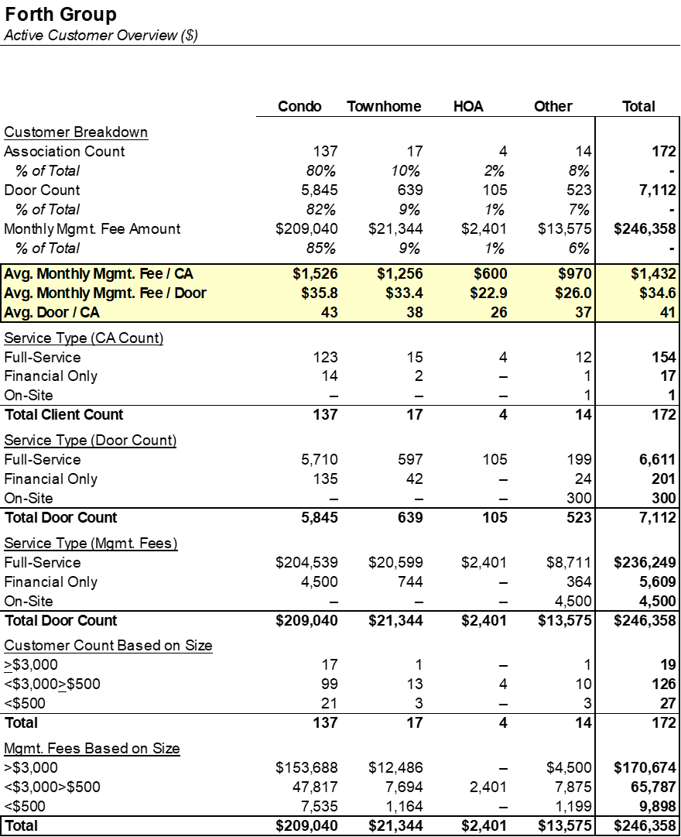

Commentary: Of Forth Group’s 172 customers, 80% are condo associations averaging ~$1,500 of monthly mgmt. fees. Scott indicated that he’d like to increase this average up to $2,000 per month. The company primarily utilizes full-service management agreements, but has steadily grown its financial-only offering. These ~$300 contracts allow Forth Group to access an underserved market without burdening managers. When talking to the leadership team, they indicated strong growth potential here, along with intentions to continue growing their remote managed segment (there are 50 remote accounts, grouped with full-service above), which allows managers to service clients without needing to go on-site. Financial-only accounts tend to have less turnover and only take up 10% of the accounting team’s bandwidth.

Customer Growth & Retention Analysis
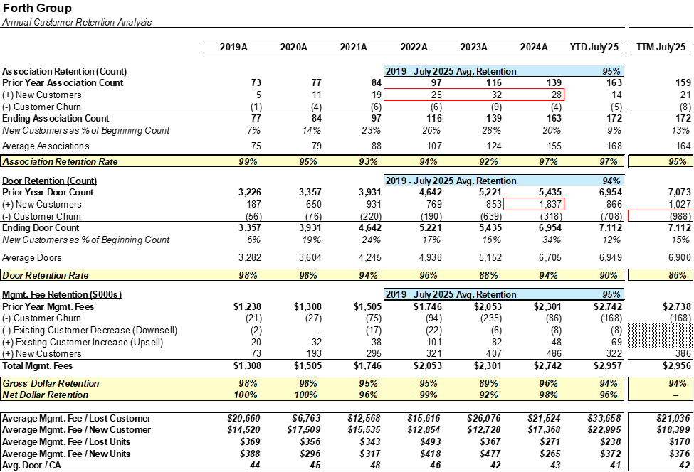

Commentary: Forth Group has effectively leveraged digital marketing to drive growth. The Company engaged an outside firm to improve its online presence, specifically through online reviews. The effectiveness of this campaign, along with SEO / SEM and web redesign, has generated significant new business since 2022. Impressively, the company has maintained 90%+ logo retention through this growth period.

Through this period of growth, Forth has been particularly successful in growing its lower cost remote (no on site visits, inspections or meetings) and accounting only services. These service models have allowed Forth to profitably service smaller associations, whose lesser needs may price out competition.

This year, the company plans on hiring a remote manager in Milwaukee to begin building a book of business in Wisconsin. The state has no licensing requirements, and having a local presence gives Forth Group the opportunity to utilize back-office resources while winning remote service clients.

Top Customers
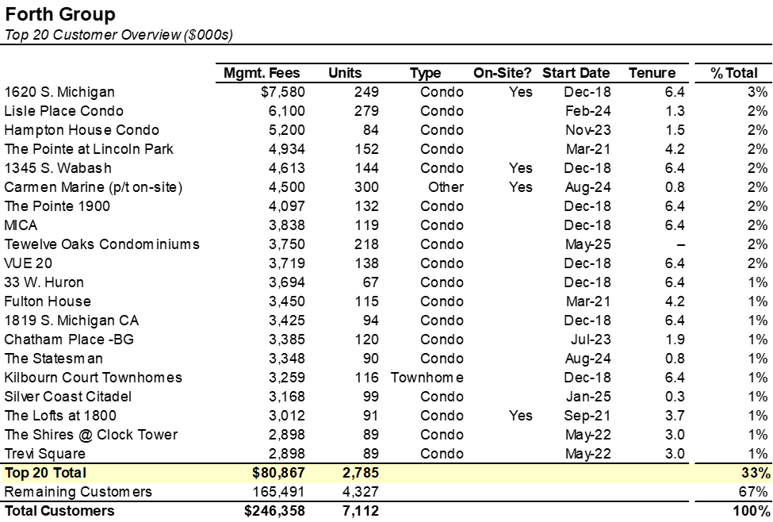

Commentary: Forth Group’s largest customer represents 3% of total revenue, and the top 20 associations represent roughly ⅓ of management fees. This is a similar dynamic to our existing Member Companies.

Customer Cohort Analysis
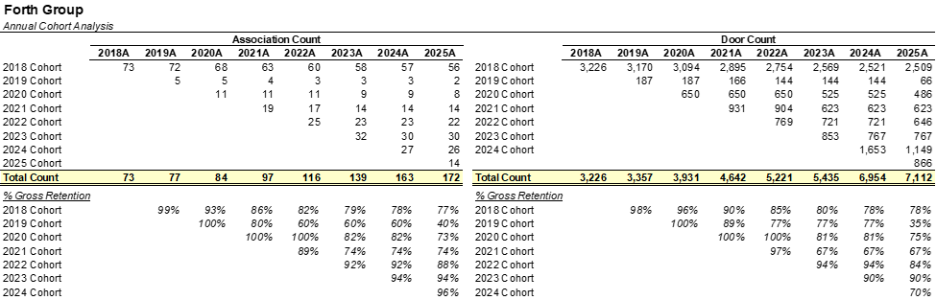

Commentary: Customer retention by cohort appears in-line with our expectations, and has been particularly strong among recent cohorts. Onboarding each cohort has become systematic, and the team has talent in place to onboard/offboard 3-6 clients per month.

Employee Overview
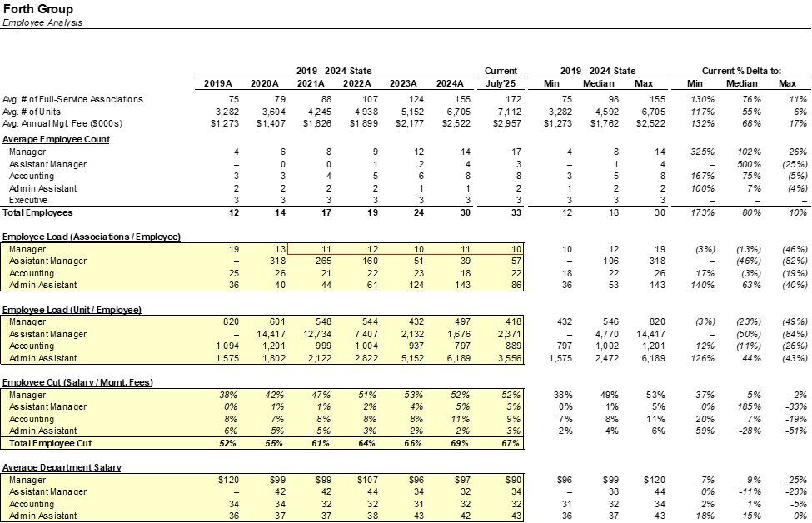

Commentary: Forth Group has 33 employees, including 17 managers, 6 of whom operate as independent vendors. Of the 8 accountants, 5 work as offshore employees, and both admin assistants are offshore. The average manager load has declined over time, but Sywia mentioned the accounting team is near capacity and would likely need additional support as the company grows.

The leadership team consists of Scott Seger, Jonathan Bierman, and Sylwia Gregorczuk. Scott is the founder, and his responsibilities include corporate accounting, payroll processing, client/employee transitions, and business development (although he has been training a replacement in this regard).

Jonathan, the VP of Development, has been with the company since 2009 and heads project management, oversees the portfolio managers, and is responsible for independent vendor managers.

Sylwia, the VP of Operations, has been with Forth Group since 2008 and manages client accounting. She also oversees the financial-only and remote management employees, along with spearheading collections and transfers.

Employee Retention
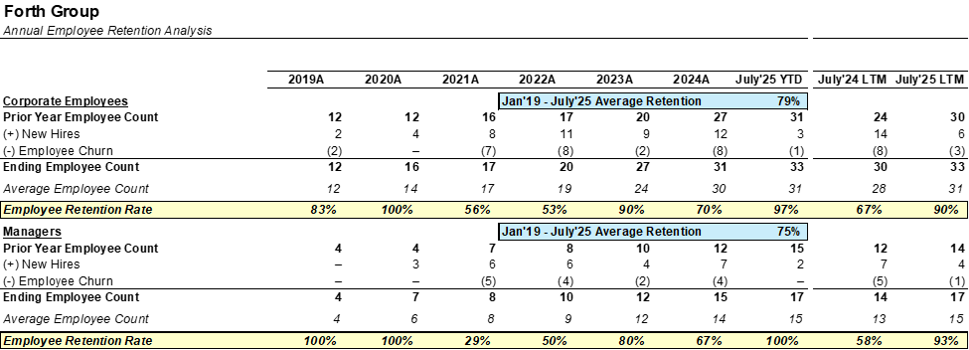

Commentary: The company has struggled with employee retention in recent years. The acceleration in customer wins overburdened personnel, and management was slow to hire the additional support needed to maintain the growing customer base. Additionally, the company was hiring people from outside the industry, which resulted in several of those hires quickly churning after receiving job opportunities in their prior line of work. Forth Group has since pivoted its approach to hiring ahead of growth, prioritizing experienced employees, and carefully monitoring the team for signs of burnout. Scott, Jonathan, and Sylwia said they’ve straightened out their recruiting process, and over the past 18 months, retention has improved.

Manager Department Overview
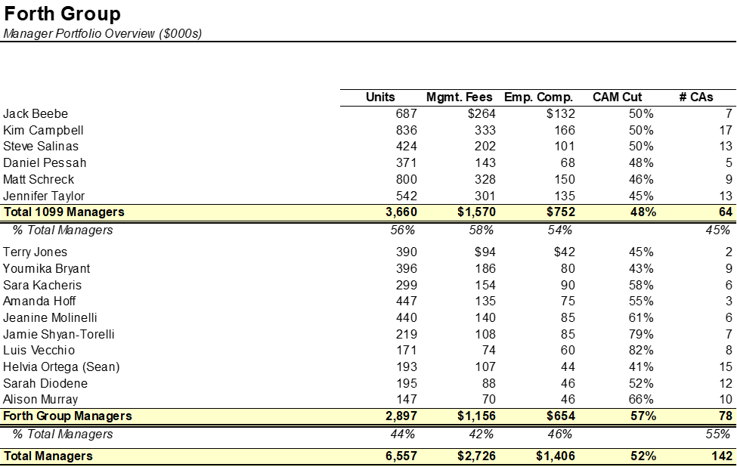

Commentary: Forth Group’s 6 independent vendor managers collectively oversee 64 associations and are responsible for slightly over half of total units, management fees, and manager compensation. The independent managers receive compensation directly tied to management fees (between 45-50%).

Chicago Market Share Analysis
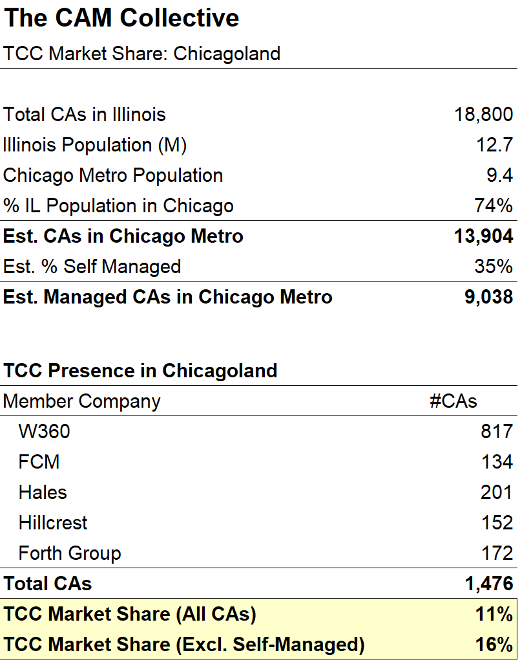
Commentary: There are an estimated ~14K community associations in the Chicago area, approximately ~5K of which are self-managed. Based on these assumptions, TCC’s member companies, including Forth Group, currently represent about 11% of the market (16% if excluding self-managed communities).

Long-Term Revenue Evolution
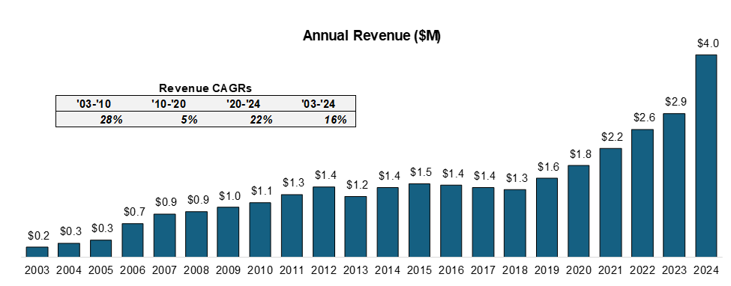

Software and Banking
Topic | Provider and Commentary
Client Accounting | Buildium
Corporate Accounting | Quickbooks
Transfers & Resales | Homewise
Corporate Payroll | ADP
Client Banking | Wintrust
Payment Processor | Forth charges $0.35 for ACH  Buildium does not charge Forth for incoming payments but charges $0.25 per outgoing EFT  Charged back to resident/association at $0.35  For CC, Buildium charges 2.99% + $1.00 (Forth charges)

